Purpose**:**

The purpose of this document is to present, in written form, a concentrated strategy for **COMMERCIAL DEVELOPER**.

This document will cover:

* Overall campaign strategy:
  + Targeting
  + Copy
  + Creative
  + Campaign Pillars
* Why we chose this direction
* What we aim to achieve with this strategy
* Budget Breakdown

**Overall Campaign Strategy:**

With the intention of this campaign being to target individuals as they walk through the skyway, we will be geofencing the 7 main towers that are adjacent to **COMMERCIAL DEVELOPER**. These towers are:

* US Bank Plaza
* Capella Tower
* Rand Hotel
* Baker Center
* CP Plaza
* Wells Fargo
* North Star Center

Because these are places of high traffic through work commutes, our intent is to reach people at times where they will be doing the most walking (breakfast and lunch).

This will also give our team accurate data as to which restaurant and stores perform the best.

Based on our team's research into the area and the objective of the campaign, we will be focusing our efforts in the first 30-60 days on 4 campaigns:

**Campaign 1: Stop By For Lunch:**

For this campaign, our goal is to target people that are passing through the Skyway during prime lunch hours. We will be promoting Taco Johns, My Burger, Kadai Indian Kitchen, and Bamboo Garden during the hours of 11am – 1:30pm. This campaign will target men and women between the ages 30-65.

Here are the creatives:

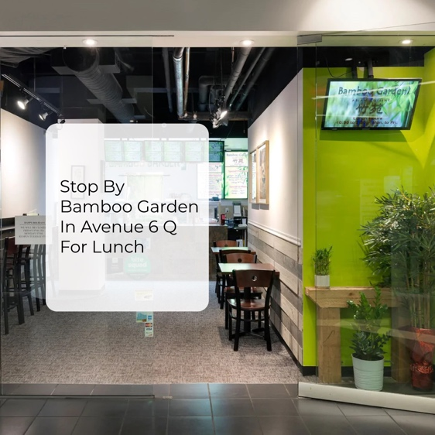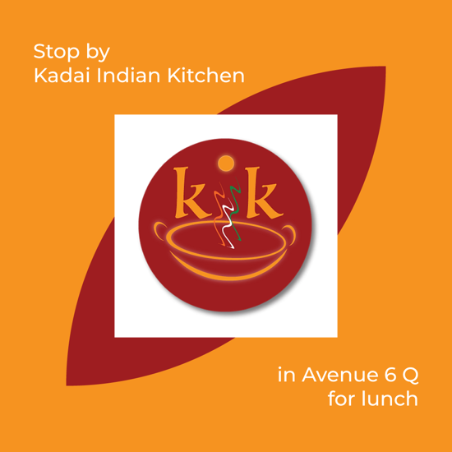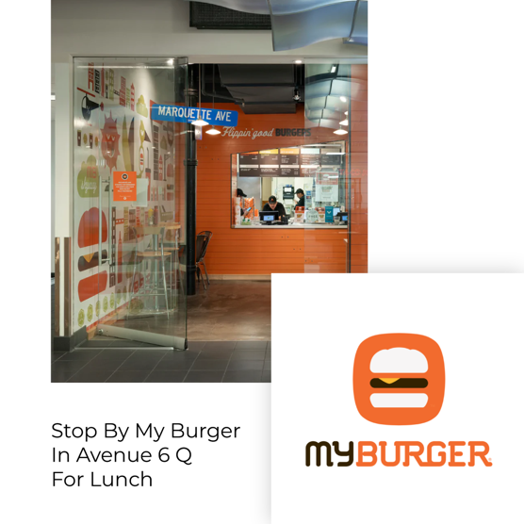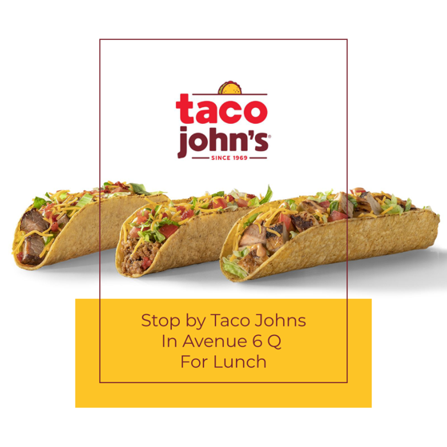

For this campaign, we will be revolving our copy around 3 main ideas:

“Taking a quick lunch break? We got you covered!”   
“Lunch doesn’t need to be boring. We make it fun!”

“Satisfy your lunch cravings with one of our spectacular dining options”  
  
**Campaign 2: Stop By For Breakfast:**

For this campaign, our goal is to target people as they are passing through the Skyway during prime breakfast hours. We will be promoting Taco Johns, My Burger, and Vitality during the hours of 7am – 11am. This campaign will target men and women between the ages 30-65.

Here are the creatives:

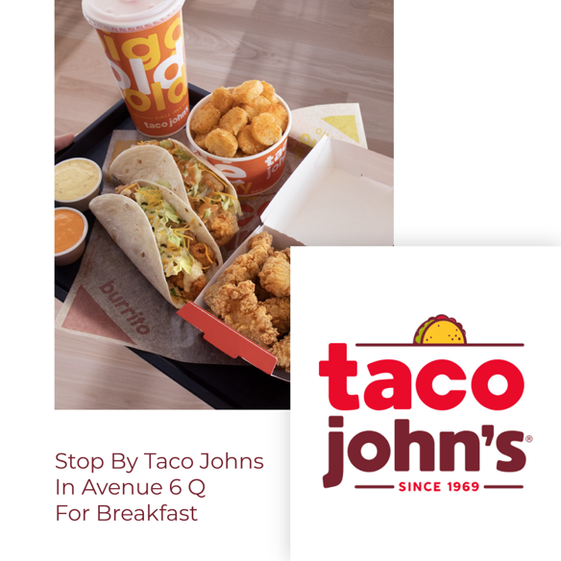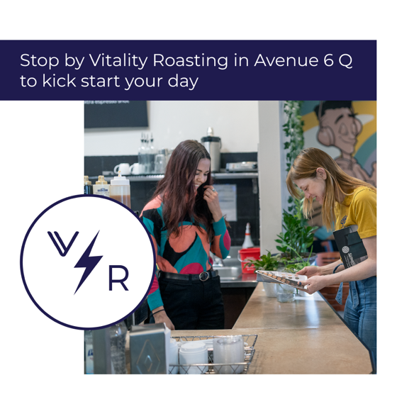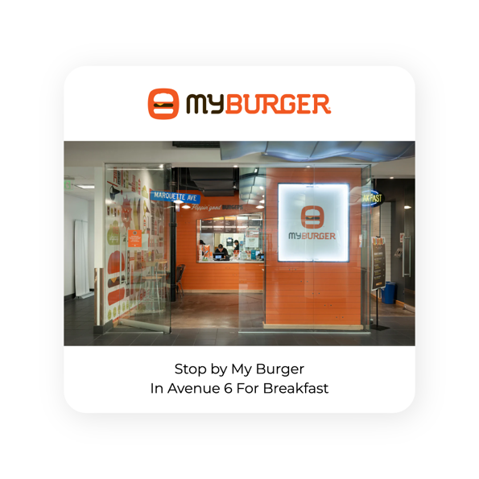

For this campaign, we will be revolving our copy around 3 main ideas:

“On your way to work? Stop in for a fresh cup of coffee or breakfast!”

“Need to jumpstart your morning? We got you covered!”

“Satisfy your morning cravings with breakfast”   
  
**Campaign 3: Staying At The Rand:** **(Optional)**

For this campaign, our goal is to target people that are currently staying at the Rand by promoting businesses that align with the Rand customers an what their needs may be. We will be promoting Vitality Roasting, Taco Johns, My Burger, Kadai Indian Kitchen, and Bamboo Garden. This campaign will be on going and target men and women between the ages 30-65.

Here are the creatives:

For this campaign, we will be revolving our copy around 2 main ideas:

“Staying at The Rand? Stop by for breakfast or lunch!”

“Looking for a change of pace? We got you covered!”

**Campaign 4: General: (Optional)**

For this campaign, we will be running an ongoing push towards the stores within the building to gather data and insights into the customer foot traffic. Using the same geographic targeting as above, we will be reaching the male and female demographic between the ages of 30-65.

Here are the creatives:



For this campaign, we will be revolving our copy around 1 main idea:   
  
“Looking for a change of pace? Avenue 6 Q has you covered!”

**Why We Chose This Direction:**

Based on our team’s research, we found a significant market size in people that work and live in the adjacent towers. This gives us the ability to reach people at prime hours on their way to and from work as well as being able to market to them after hours as a convenient option for breakfast, lunch and any other occasion.

Based on our research, we found that most of the people within the Skyway system are:

* Male and Female
* 30-65 with the median age being 32
* Average Household income of $72,000/year

With the goal being to attract the most people within the Skyway and retrieve data, we found it best based on our models to keep the age between 30-65 and narrow it as the campaigns become more antiquated while maintaining income targeting of the top 50%.

**What We Aim To Achieve With This Strategy:**

With this strategy, our team aims to achieve the following information:

* Figure out the “who” in the foot traffic within Avenue 6 Q
* Understand which businesses are anchor businesses
* Examine which copy and creative style resonates the most with buyers
* Interpret data to Abdo Market House that allows them to expand upon their buyer profile and subsidize marketing for their tenants

**Budget Breakdown:**

Based on the above campaigns, here are the following budget options given the $1,000/month allocation:

**Option 1:** (Best Option)

Campaign 1: Stop by for Breakfast: $500/Month

Campaign 2: Stop by for Lunch: $500/Month

**Option 2:** (Third Best Option)

Campaign 1: Stop by for Breakfast: $333/Month

Campaign 2: Stop by for Lunch: $333/Month

Campaign 3: Staying at The Rand: $333/Month

**Option 3:** (Second Best Option)

Campaign 1: Stop by for Breakfast: $333/Month

Campaign 2: Stop by for Lunch: $333/Month

Campaign 4: General: $333/Month

**Option 4:** (Fourth Best Option)

Campaign 1: Stop by for Breakfast: $250/Month

Campaign 2: Stop by for Lunch: $250/Month

Campaign 3: Staying at The Rand: $250/Month

Campaign 4: General: $250/Month