Water damage is no cost-effective venture. In fact, here are some numbers to put into perspective what water damage can cost:
- Insurance companies pay out $2.5 Billion dollars per year for water damage repairs
- The annual cost of water damage to Americans is $13 billion dollars
- 14,000 Americans face a water damage emergency daily
- The average home insurance claim for water damage is $10,000
- 98% of basements will suffer from water damage within its lifetime
It’s no wonder that water damage is a homeowners' worst nightmare.
The good news? Most water damage can be prevented—in fact 93% of all water damages are preventable! So how do you avoid disaster and head off those high repair bills in advance? Here are 10 ways to keep your home dry:

1) Install water detection devices.

Many people have a false sense of security when it comes to plumbing, but sooner or later, you will experience water damage if you don’t take the proper preventative measures.
With newly introduced devices such as Leaksmart with their smart valve technology, preventing water damage is as easy as installing sensors around your home and downloading their app to receive notifications when there is a leak in your plumbing system.
Another great feature of Leaksmart that can help save your home from any potential catastrophes is their automatic valve shut off. When Leaksmart detects a leak, it automatically shuts off your water main, preventing water damage and allowing you to take corrective action before it’s too late.
You can find their technology here: https://leaksmart.com
Our team recommends: Installing a leak detection device like the Leaksmart.com device so you can stay in the know on your pipes and receive notifications in the event a leak is detected.

2) Maintain appliances.
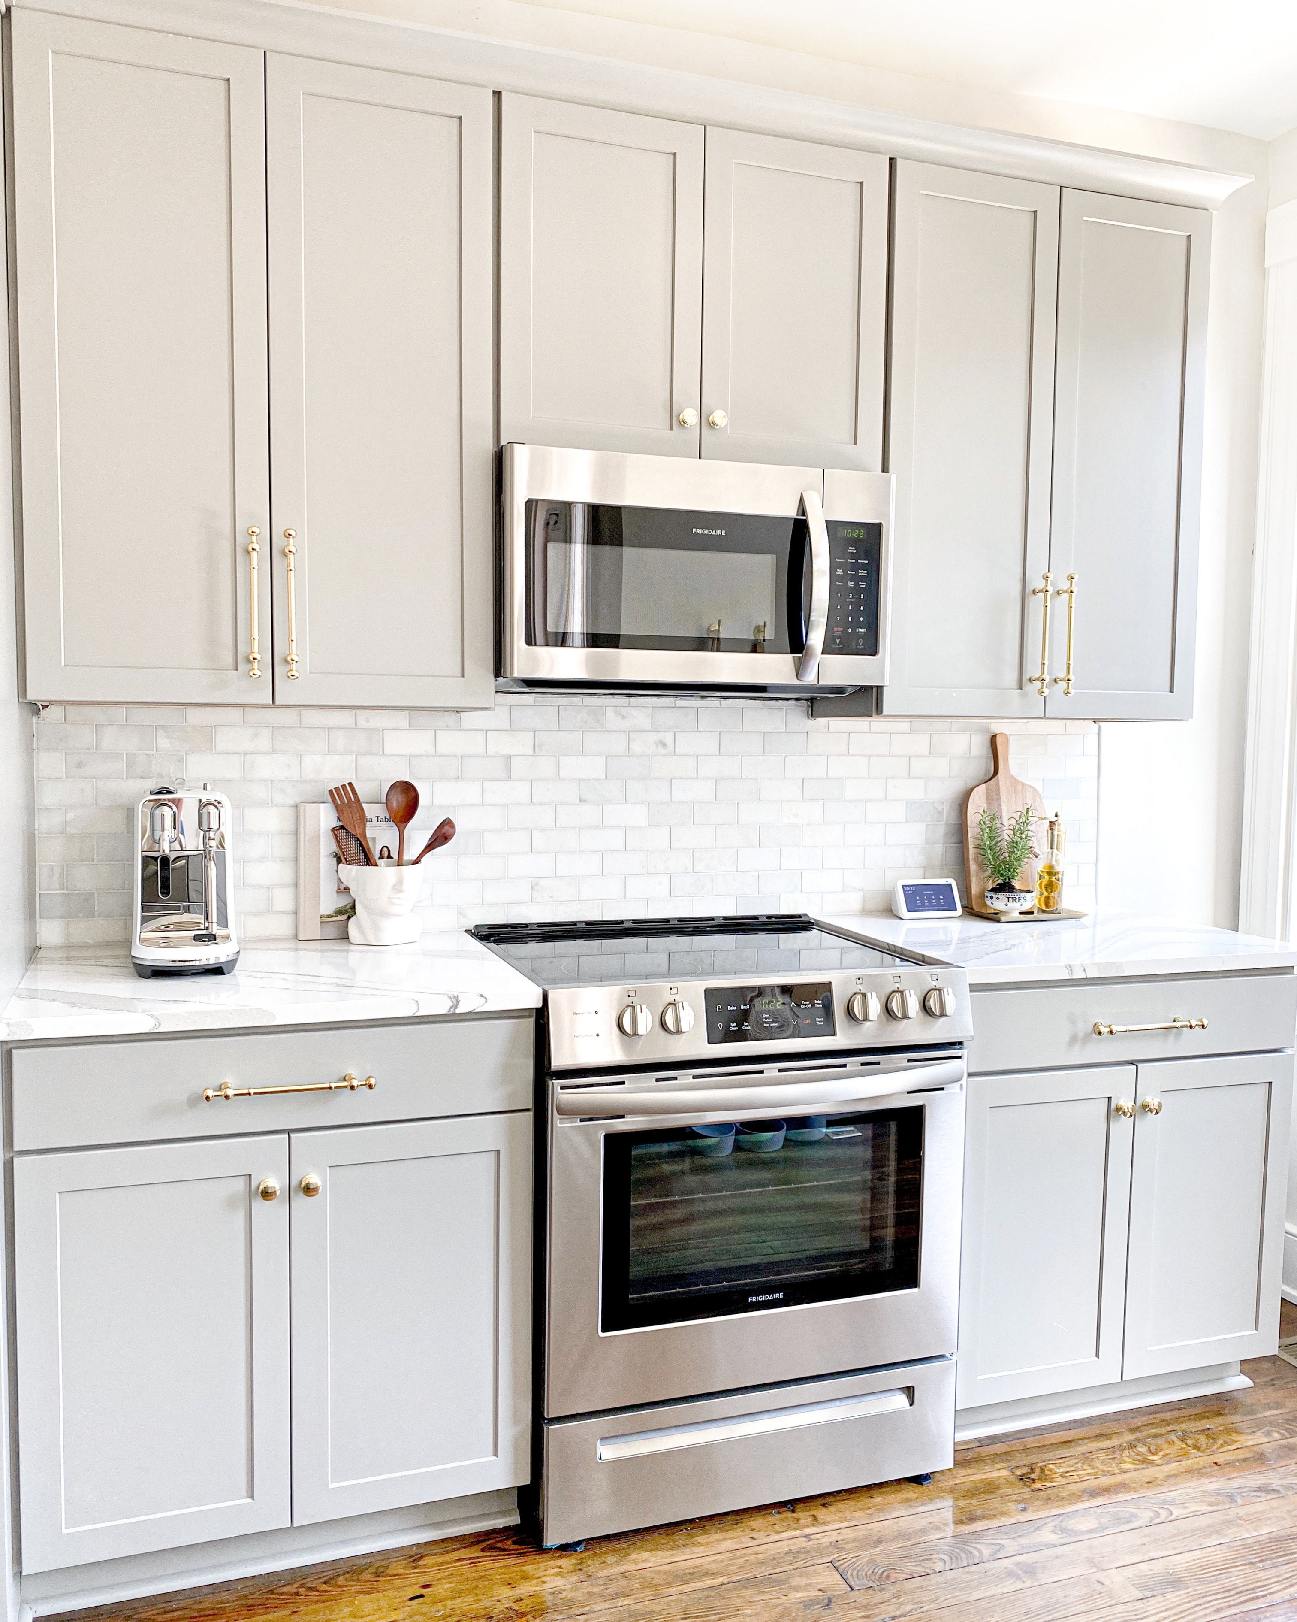
Water damage can come from many different sources, and the cause of the damage is often overlooked. Things like, broken hoses, overflowing washing machines, or even a leaky dishwasher spells trouble if ignored for too long.
Sure, maintaining your appliances can be a tedious and time-consuming task, but it’s worth the effort when you consider that doing so may save you from costly repairs in the future.
This is why, an action as simple as inspecting your appliances regularly can save you thousands in repair bills. A quick look at the laundry hoses, dishwasher, washing machine, refrigerator, sink (and the pipes underneath it), HVAC system, water heater, even your toilet and shower will save you thousands in water damage repairs. We recommend checking your appliances for leaks at least once a month depending on how often that appliance is used.
Aside from checking your appliances every month, it’s also a good idea to have parts like hoses replaced every 3 years to prevent damage that may occur from wear and tear.
The benefits of maintaining an appliance are plentiful: not only will these steps help avoid damage to aging equipment which could lead to even more expensive repair bills down the road (such as replacing broken parts), it also helps prevent water damage in your home, and it helps you save money on energy consumption.
Our team recommends: Checking and maintaining appliances at least once a month to make sure no leaks are occurring in addition to having parts like hoses replaced every 3 years.

3) Know where your water main shut-off valve is, it’s important!
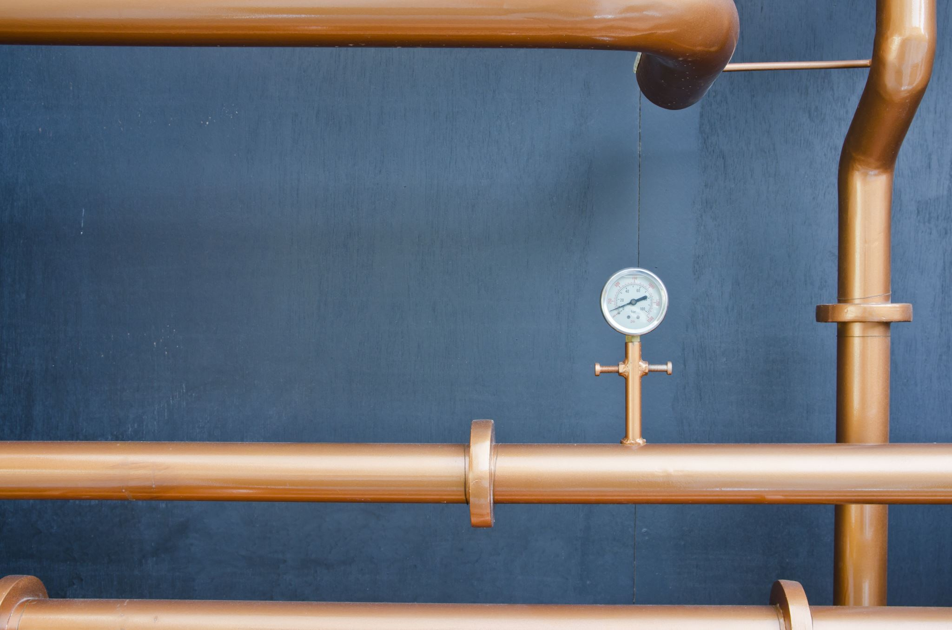
Why is your water main shut-off valve so important? A house's plumbing system can do nothing but fail when a water line break interrupts the flow of potable, clean drinking water. This event will result in both an inconvenient and costly repair to you as well as potential damage that could be avoided with some knowledge and preparation.
Finding your water main shut off valve is easy, but it depends on how your house is built. Here is our quick guide for finding your shut-off valve:
Is your home built on a slab? Check either under or on top of your water heater tank! It will either be shaped like a ring or a lever.
Does your home have a basement? If you have a basement, you’ll likely find your water main shut-off valve there. The best place is near where your outdoor hose is just on the other side of the wall.
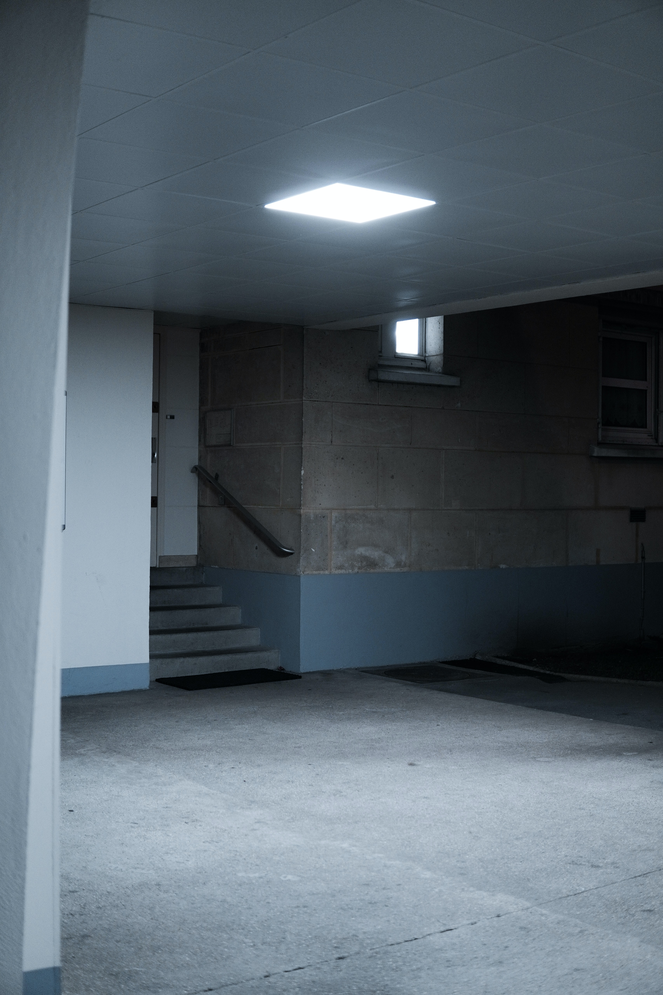
Does your home have a crawl space? Your water main valve may be located under the crawl space. Check on the front wall of the house.
Last resort: Still can’t find your water main shut off valve? No problem! You can shut your main water line off from the main city water line, this can be found in a covered box at the front of the house.
Your home has one key tool to address any emergency situation - its own shut-off mechanism. Know where the shut-off valve is in instances of emergencies.
Our team recommends: Taking the time to check where your water main shut off valve is so you can protect yourself in the event an emergency arises,

4) Clean Gutters and Downspouts.

Have you ever had a water pipe burst and ruin your home? Cleaning out the gutters at least twice yearly around the late fall or early winter and early spring will help prevent that.
Let's face it, we can’t prevent mother nature from behaving. As mother nature does what she does best, things like leaves, dirt, debris, and sticks can fall into your gutters resulting in clogged gutters. Clogged gutters can create excess buildup of water which can trickle through cracks and crevices in the siding. If this trickling goes unaddressed, overtime the water compounds and the effects can be costly. Our team recommends cleaning your gutters around the late fall or early winter because it’s best to wait until as many leaves as possible have fallen off the trees.
Another tip is to direct downspouts further away from your home! Water damage is less likely to occur when downspouts direct water further away from the house. Our team recommends directing water damage at least 5-10 feet away from your house.
Our team recommends: Cleaning your gutters and downspouts every 6 months around the late fall or winter and in the spring

5) Take temperature into consideration.

Chances are, you live in an environment where the temperature can change based on the time of year. For some places, the weather change is more extreme. Because of this, it’s important to know the climate in your region. Knowing your regions climate could save you from broken pipes, flooding, and even water damage.
When it comes to temperature fluctuations during different seasons of the year, you should consider what type of things might happen that can affect your piping system. In cooler climates, the risk for water is higher as homes deal with pipes freezing more often. To keep pipes from freezing, pay attention to your thermostat. Even if your home is vacant, it’s never a good idea to let the thermostat get at or below 50 degrees. Another practice our team recommends is to be gentle with the thermostat. Significant changes in the thermostat between daytime and nighttime activity increases the risk of pipes freezing.
In addition to considering thermostat changes, it’s also a great idea to ensure your thermostat is operating properly. This could mean changing the batteries or even making sure that the thermostat level as a thermostat that is not level can alter the accuracy and internal component.
Our team recommends: Monitoring your thermostat year-round and being mindful of freezing pipes in regions with cooler climates or regions with extreme temperature fluctuations

6) Examine Doors and Windows.

Imagine waking up one morning to the sound of rain pouring down on your roof. You walk outside and water is seeping through windows, doors, and cracks in the walls; you can see it from all over your property! The worst part about severe weather? It's not just a nuisance: life-threatening disasters like hurricanes or tropical storms are capable of breaking glass leading to flooding inside households resulting in costly damages such as mold infestations that could be prevented with proper preparation beforehand.
No matter where you live, nasty weather can happen at any time - especially during hurricane season near regions close to the tropics where damaging storms like hurricanes and tropical storm winds break window panes causing damage indoors including water accumulating which leads to expensive home repairs due
Don’t live near the tropics? You’re not completely out of the woods. Tornados, micro bursts and severe thunder storms can have the same effect on your home. After a storm impacts your area, even if your home was not in the direct impact zone, it’s best to examine your doors and windows any cracks, glass damage or damage to the seal.
Our team recommends: Checking window and door seals before a storm and after a storm occurs in your area to make sure there is no significant damage that could lead water leaking into your home.

7) Know your landscape architecture.
The type of land where you live can have a drastic impact on your home, from the piping to how well it's insulated. Landscape interference with pipes is also something that may need to be considered.
The way in which both the location and landscape of one’s property will affect their plumbing system is worth considering when seeking out possible designs or plans for additions like patios or gardens near structures made up primarily by either water lines or gas pipes respectively; these considerations are especially important if any changes are going to happen close enough that they could possibly interfere with each other.
As you begin to make changes to your landscape design, they can sometimes become wrapped around your homes piping system which adds extra pressure to your pipes or sprinkler lines. Calling a professional to come to your house and inspect for landscape designs that may be putting extra pressure on your pipes which can cause them to crack is always a great idea.
In addition to roots becoming wrapped around pipes, changes to your landscape design can affect water flow and distribution! Overtime, water flow and distribution can accumulate and cause a considerable amount of water damage when left unchecked.
Our team recommends: When considering significant landscape changes, call a professional to check your property and how it affects your plumbing system. In addition, it may also be a good idea to check where shrubs and trees are located to ensure that no roots are applying unnecessary pressure to pipes.

8) Install an automatic watering system.

Having a beautiful yard is hard work. After all, you spend so much time making sure it looks good and taking care of the plants.
However, some people spend so much time taking care of their yard, that they don’t realize the potential risk of water damage.
Installing an automated home garden system will help moderate how often your lawn needs watered as well as direct water away from your house. This helps keep excess water away from your foundation and other areas where water damage could develop.
Our team recommends: Installing an automatic irrigation system so you can ensure that you moderate the amount of water being used for gardening as well as guaranteeing that water gets redirected away from your home accordingly.

9) Opt for a drain snake over chemicals
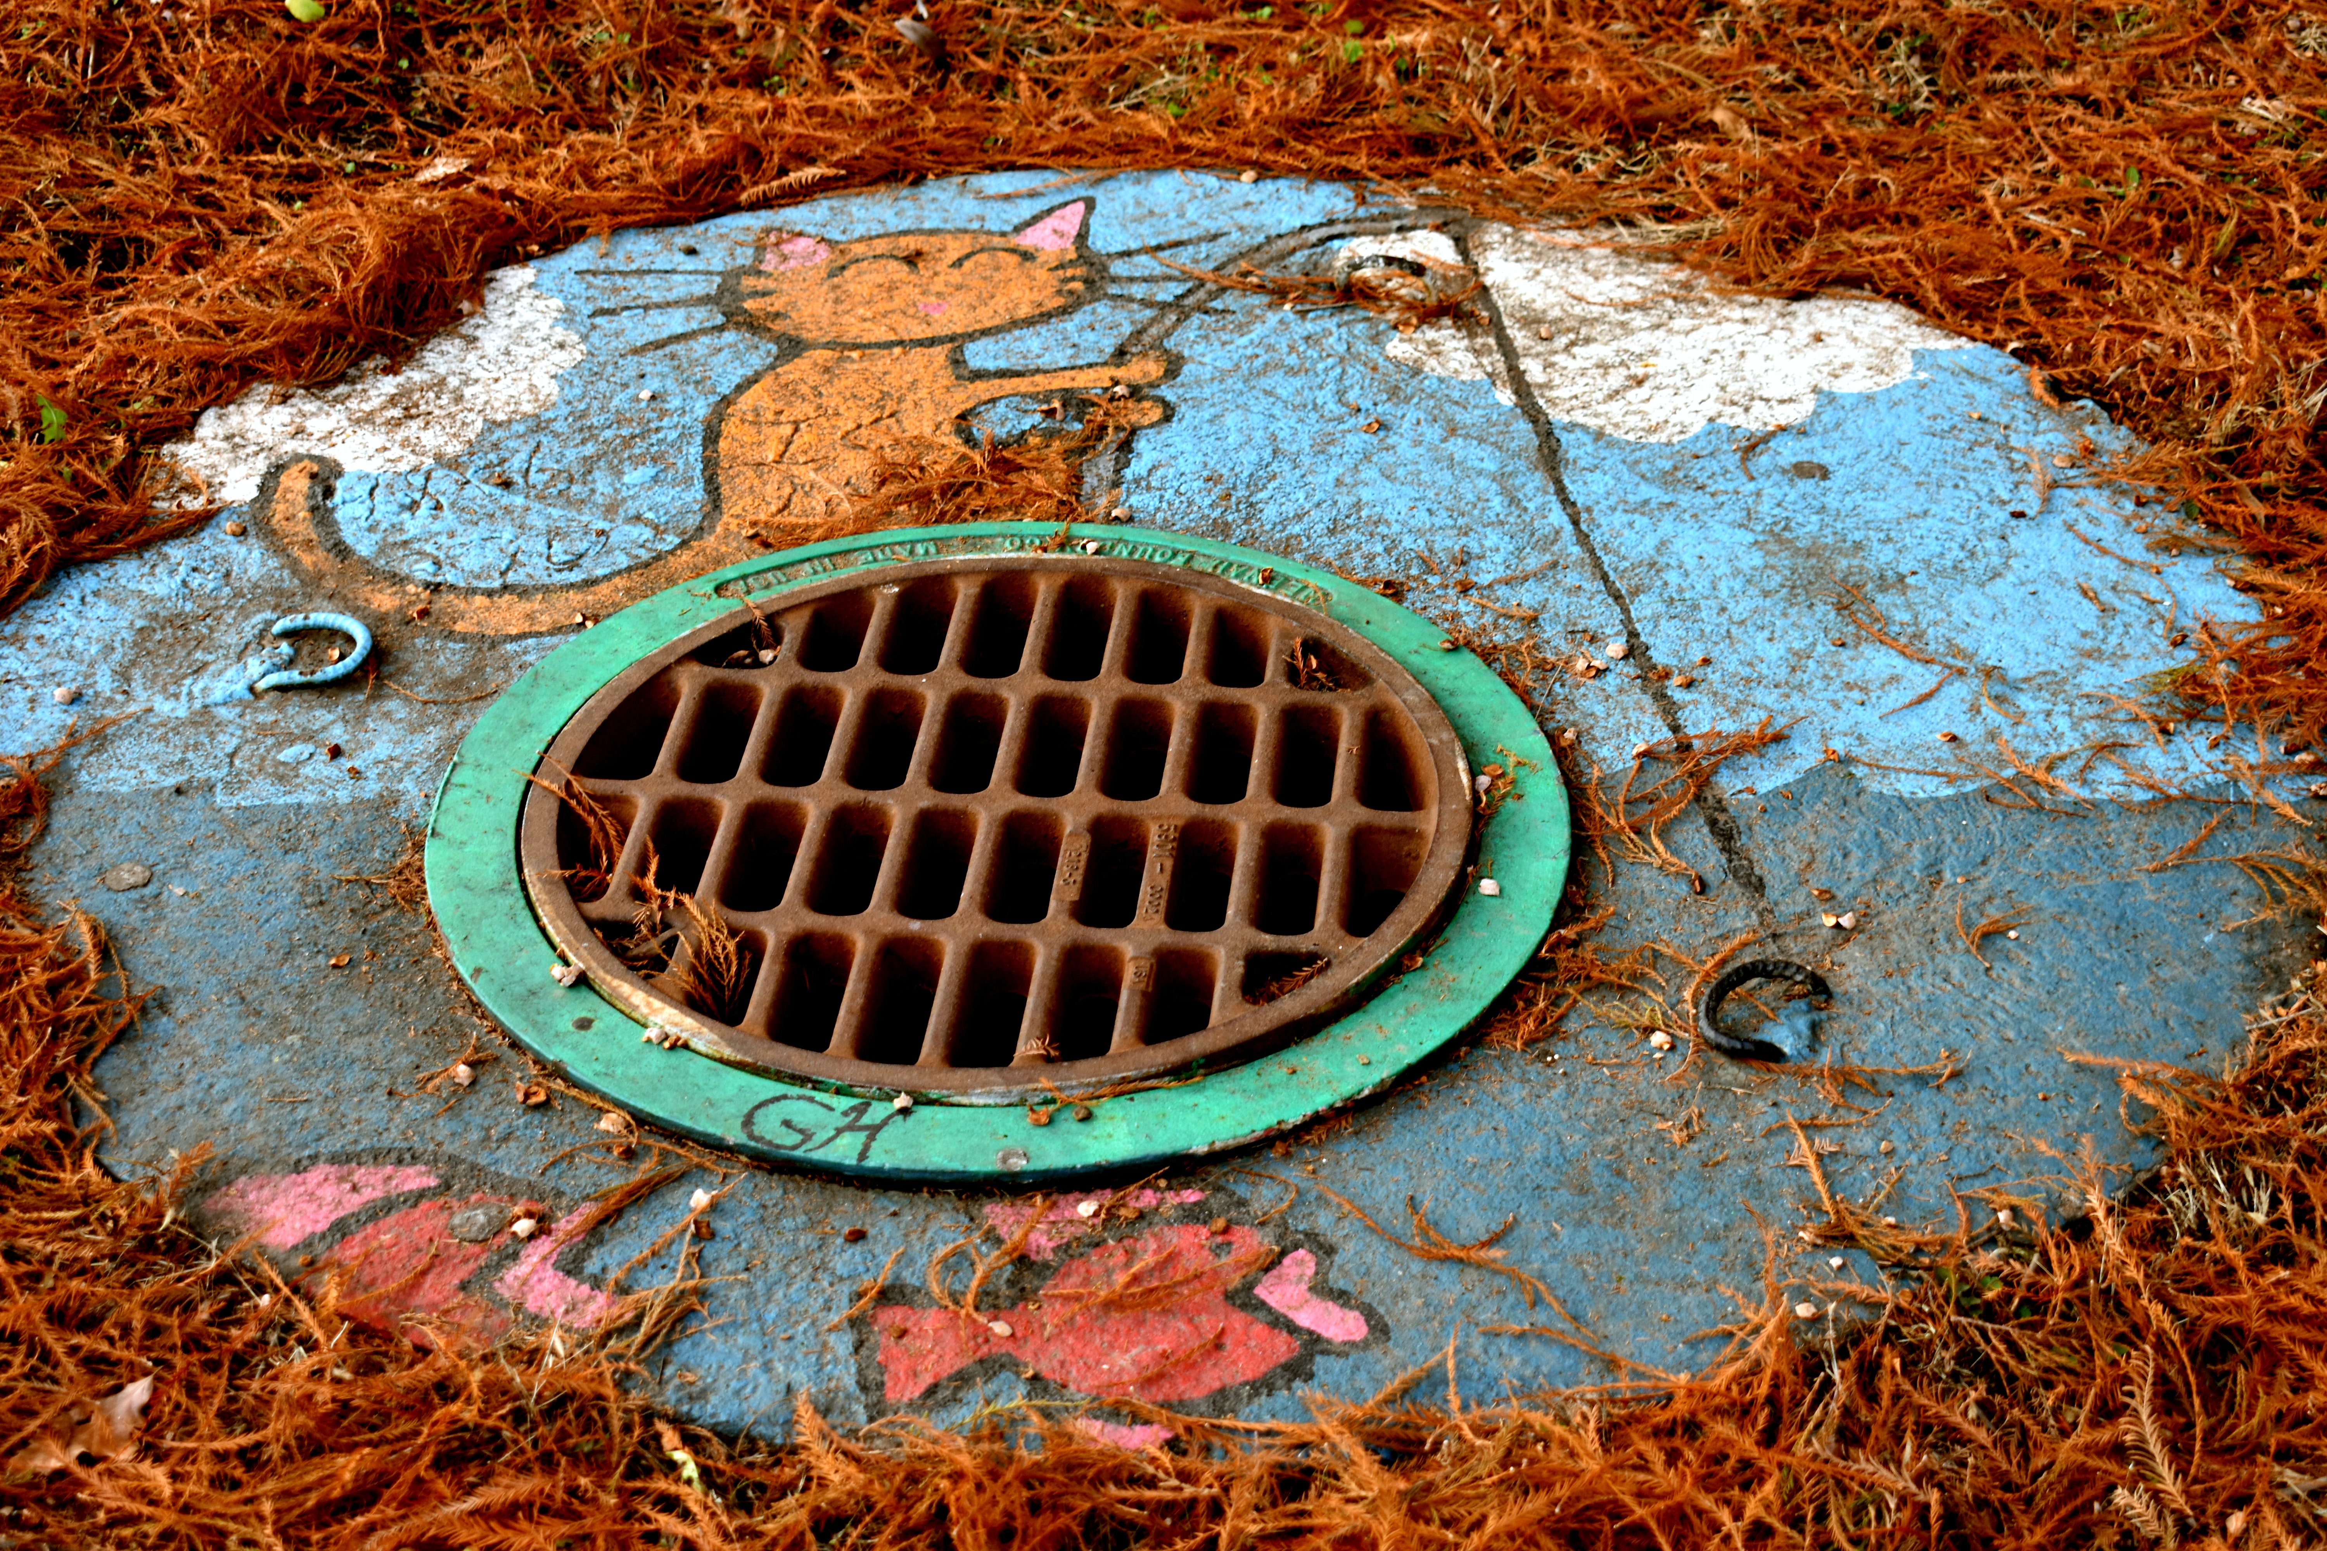
When pipes get clogged, it’s a homeowners first instinct to unclog it as soon as possible. This usually means going to the closest store and buying chemical products like Drano to unclog your toilet. While at first, this may make a lot of sense, it’s actually damaging to your pipe system.
The unfortunate reality is that a lot of these products contain chemicals that can eat at your pipes over time causing them to become weak and leading to water damage. Our team recommends taking a second consideration and reaching for the drain snake instead! This way, you can get the job done and you lessen your risk of water damage!
Our team recommends: Consider reaching for the drain snake over the unclog product when faced with the decision. This way, you can ensure you aren’t damaging your pipes with the chemicals that are in the chemicals

10) Monitor your water bill

Ever thought about why you’re paying more for water? It might not be because of the drought. Unusual jumps in your monthly bill can point to a problem with the pipes, so it's always worth checking out if that could be what is going on before calling an expensive plumber or even calling our team to fix water damage. If there turns out to be no leak, don't feel bad at all-- just chalk it up as another one of life's mysteries like where socks go when they disappear from inside our laundry basket or how we got those unsightly bags under our eyes overnight.
Our team recommends: Monitoring your water bill for any unusual jumps and taking into consideration a possible pipe leak as causation of the jump in your water bill.

